Project Design Phase-II
Technology Stack (Architecture & Stack)

Date | 03 August 2026
Team ID | NA
Project Name | Book A Doctor
Maximum Marks | 4 Marks

Technical Architecture:
The deliverable includes the architecture of the Book A Doctor web application developed using the MERN Stack. The architecture consists of:
Example: React.js frontend for Patients, Doctors, and Admin.
Reference: https://www.mongodb.com/resources/languages/mern-stack

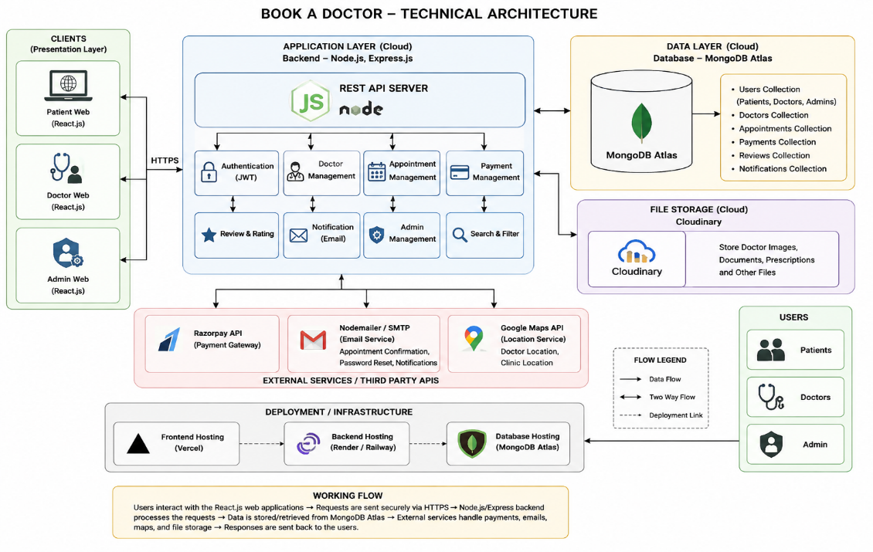
Guidelines:
- Include all application modules (Patient, Doctor, Admin).
- Show Local/Cloud infrastructure and database. Indicate external APIs (Razorpay, Cloudinary, Email).
Table-1 : Components & Technologies
S.No | Component | Description | Technology
1 | User Interface | Responsive web interface for patients, doctors and admin | React.js, HTML5, CSS3, JavaScript, Bootstrap
2 | Application Logic-1 | User Authentication (Login, Registration, JWT Authentication) | Node.js, Express.js, JWT, bcrypt
3 | Application Logic-2 | Doctor Management (Doctor Profiles, Specializations, Availability, Search & Filter) | Express.js, Node.js
4 | Application Logic-3 | Appointment Booking, Payment, Notifications, Admin Dashboard | Node.js, Express.js
5 | Database | Stores patient records, doctors, appointments, payments and reviews | MongoDB
6 | Cloud Database | Cloud-hosted MongoDB database | MongoDB Atlas
7 | File Storage | Doctor profile images and documents | Cloudinary
8 | External API-1 | Online Payment Gateway | Razorpay API
9 | External API-2 | Email Notification Service for appointment confirmation | Nodemailer (SMTP/Gmail)
10 | Machine Learning Model | Doctor recommendation based on specialization and patient search (Optional Future Enhancement) | Recommendation Engine (Future Scope)
11 | Infrastructure (Server / Cloud) | Frontend deployment, Backend deployment and Database hosting | Vercel (Frontend), Render/Railway (Backend), MongoDB Atlas (Cloud Database)

Table-2 : Application Characteristics
S.No | Characteristics | Description | Technology
1 | Open-Source Frameworks | Frontend and Backend frameworks used | React.js, Express.js, Node.js, Bootstrap
2 | Security Implementations | Password encryption, JWT authentication, Role-based access, Input validation, HTTPS, OWASP practices | bcrypt, JWT, Helmet.js, Express Validator
3 | Scalable Architecture | Three-tier architecture separating Presentation, Business Logic and Database layers | MERN Stack, REST API Architecture
4 | Availability | Cloud deployment with highly available database and server hosting | MongoDB Atlas, Vercel, Render
5 | Performance | Fast API responses, Indexed MongoDB collections, Image optimization, Lazy loading, React optimization | MongoDB Indexing, React Optimization, Cloudinary CDN

References:
• MongoDB MERN Stack Documentation – Official guide for building MERN stack applications using MongoDB Atlas and React.
• MongoDB React Integration Guide – Official documentation for integrating React, Express, Node.js, and MongoDB.
• MERN Stack Explained (MongoDB) – Explains the three-tier MERN architecture, components, and application workflow.
• Razorpay API Documentation – Official payment gateway API documentation used for online appointment payments.
• DigitalOcean MERN Stack Documentation – Reference for deploying and hosting MERN stack applications.

